**Chapter 6**

**Projecting Tax Changes Over Time- Growfactors**

**Individual Income Tax**

The microsimulation model can be used to project tax changes over time. This is essential for two reasons- (i) The data available with us may be of past years and may not reflect the present picture fully, so we may need to update past data and (ii) When simulating policy reforms, we may be interested in the impact taking place in future years, for which no data is available. Therefore, it becomes essential to have the capability to project variables of the microsimulation model across years and into the future. This functionality is achieved with the help of certain multiplicative factors called ‘growfactors’. There are certain points to be noted:

1. As a matter of principle, growfactors are only applied to ‘Read’ variables and not ‘Calculated’ variables in the model. This is because ‘Calculated’ variables are being calculated within the model and it is not prudent to manually inflate or deflate them. Since ‘Read’ variables are being directly read from the data, it is apt to project these variables using growfactors and then allow the model to carry out all its calculations.
2. Growfactors have to be estimated separately- they are not calculated or estimated by the microsimulation model. In other words, the microsimulation model takes growfactors as an input. Estimation of growfactors can be done based on past data or some kind of regression modelling which is a separate exercise.

**How growfactors are incorporated in the Model**

The files pertaining to growfactors are contained in the repository ‘pitaxcalc-data’ within the folder ‘taxcalc’. The relevant files are-

1. Growfactors.csv- An Excel file containing the actual growfactors.
2. Growfactors.py- A python file which reads in the csv file.
3. Records.py- This is the python file which prepares the data for use by the tax calculator. The grow factors are applied to the relevant variables in this file.

Growfactors.csv

A snapshot of growfactors.csv is given below-

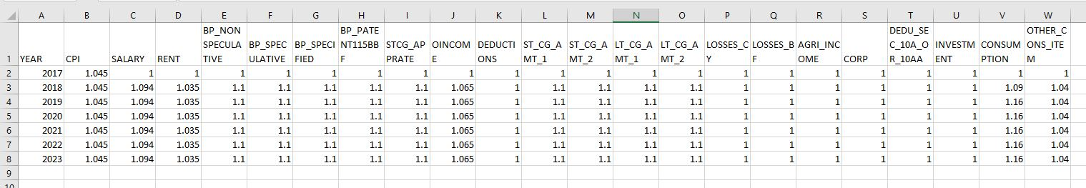

**Figure 1: Growfactors.csv**

As can be seen from figure, the column ‘Year’ contains the years for which we want to project the data. In the current model, we are projecting the data upto 2023. The different columns contain the various Read variables for which we want to project into the future such as ‘Salary’, ‘Rent’ etc. At present, a rudimentary growth factor has been taken to run the model such as 3.5% growth rate per year for Rent and 9.4% growth rate per year for Salary etc. These grow factors will be refined with time.

As new Read variables are added to the model, they can be added as new columns in the growfactors.csv file.

Growfactors.py

Growfactors.py contains the growfactors class. The purpose of this file is to read in the data from the csv file. A snapshot of the code is given below-

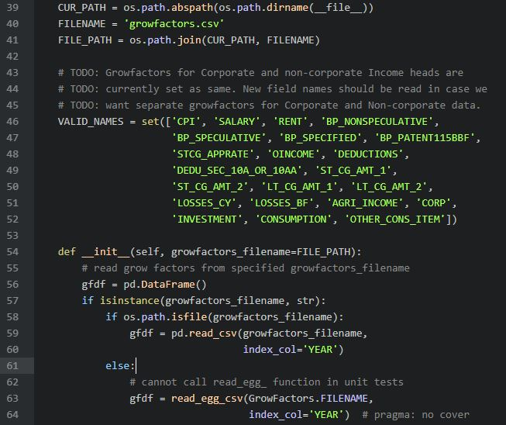

**Figure 2: Snapshot of growfactors.py**

As can be seen from the figure, FILENAME is being specified in line 40 as growfactors.csv. Thereafter, in line 56, an empty Data frame is created and in line 59, the data frame is filled in by reading the csv file, using the *read_csv* command.

Lines 46 to 52 contain the names of all the variables contained in growfactors.csv which must be specified for the Python program. These variables are stored as a Python set- VALID_NAMES. As new variables are added to growfactors.csv, they must be added to VALID_NAMES.

Records.py

When Records.py runs, it calls growfactors.py which in turn reads in the data from growfactors.csv. Records.py now applies the growfactors to the actual variables in the data. A snapshot of the code within records.py which does this is shown below-

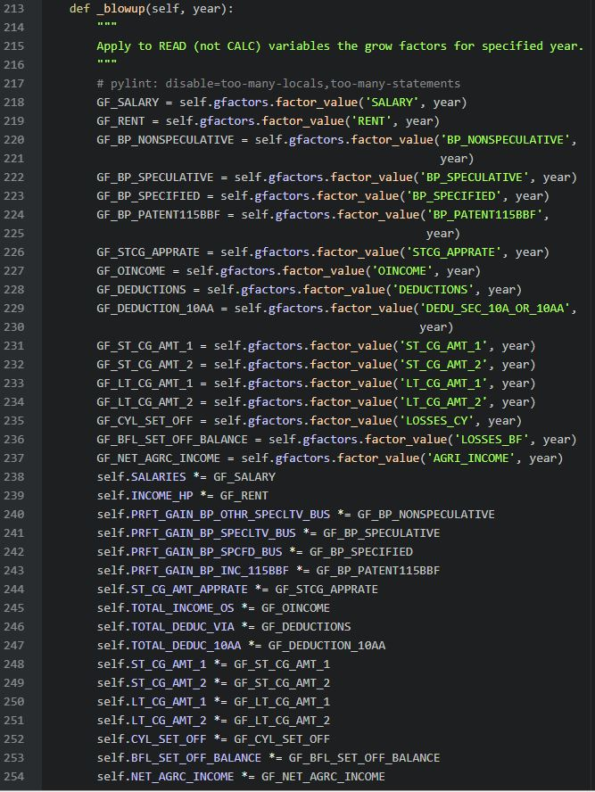

**Figure 3: Snapshot of records.py**

As can be seen from the figure, Lines 218 to 237 call the different growfactors. These are assigned as GF_SALARY, GF_RENT etc. Thereafter lines 238 to 254 multiply the relevant variables in the records (i.e data) with the growfactors ( done by the *= command).

Workflow for projecting new variables using growfactors

As the model is expanded and new variables need to be projected into the future, the following steps need to be undertaken-

1. In growfactors.csv, add new columns containing the names of the variables to which grow factors need to be applied. These should be ‘Read’ variables and not ‘Calculated’ variables.
2. Fill in the growfactors for the relevant years in growfactors.csv through an estimation or regression analysis.
3. In growfactors.py, add the names of the new variables in VALID_NAMES, as shown in Figure 2.
4. In records.py, add the new variables after Line 237 as shown in Figure 3, with the prefix GF_.
5. Beneath Line 254 shown in Figure 3, write the same command with the new variable.